Lab 2: Blackboard Testing and Logic Block Development
Lab Worksheets should be filled out during your lab section and then completed
(adding Conclusion Topic responses) and submitted on D2L by Sunday at 11:59pm.
Student Name: Kyle Rush

Lab Worksheet
Complete this sheet as you complete the lab.

Pre-Lab
Section 2.1
- How many switches are available on the Blackboard?
12 switches.
- How many single-color LEDs are there?
10 single color LEDs
- Our plan is to implement the 2:1 MUX on the Blackboard. To do so, we will link our module inputs and outputs to various locations in hardware. Which of the above circuits should we connect to the MUX inputs? How many do we need?
We need to connect slide switches as inputs, and thus we need 3 switches (a, b, s0)
- Which hardware circuits should we connect to the MUX outputs? How many do we need?
1 single-color LED
- Later in this lab, we will build a 4:1 MUX and implement it on hardware. How many inputs (total inputs and select lines) do we need?
We would need 6 inputs (4 input, 2 select).
- Does the Blackboard have enough inputs for this task?
Yes
Section 2.2
- What additional file(s) do we need to link our software to the hardware?
A constraint file that defines the hardware.
- We are going to use vectors for the connections to the external pins. For simplicity, we will continue to use our ongoing code standard of in0, in1, in2… and s0, s1, s2, etc for our modules. However, suppose we wanted to set up our 2:1 MUX from Lab 1 where the two inputs are a vector. Provide the identifier declaration below. Assume it is a wire, as is always the case for our source modules.
input wire [1:0] inp;
- Creating your own hardware connections requires a lot of knowledge about the FPGA itself and, in our case, the surrounding hardware. We will take care of this for you by providing you with a constraint file. However, some knowledge is always useful. Review the summary of the constraint code on page 2 of the Blackboard Tutorial on D2L. Our constraint file is located at the bottom of the document, and is the same as the one in the RealDigital tutorial. Is there any sense in us connecting pin W14, if we will not be using any hardware other than the switches and LEDs we discussed above? Explain.
W14 is a button, and since we will not be using it there is no reason to connect the switch to any wire because it will do nothing and will be unused code that makes it harder to read anyway. Also, the synthesis could throw an error when trying to build the modules.
Section 2.3
- Include your logic block sketch below. If you can’t draw on paper and scan with your phone, and if you can’t use a tablet, and if you won’t want to use MS Paint, you can use draw.io, a free online diagram drawing tool. At the bottom left, if you click on “More Shapes”, then under “Other”, there is an electrical symbol set that includes basic logic symbols.
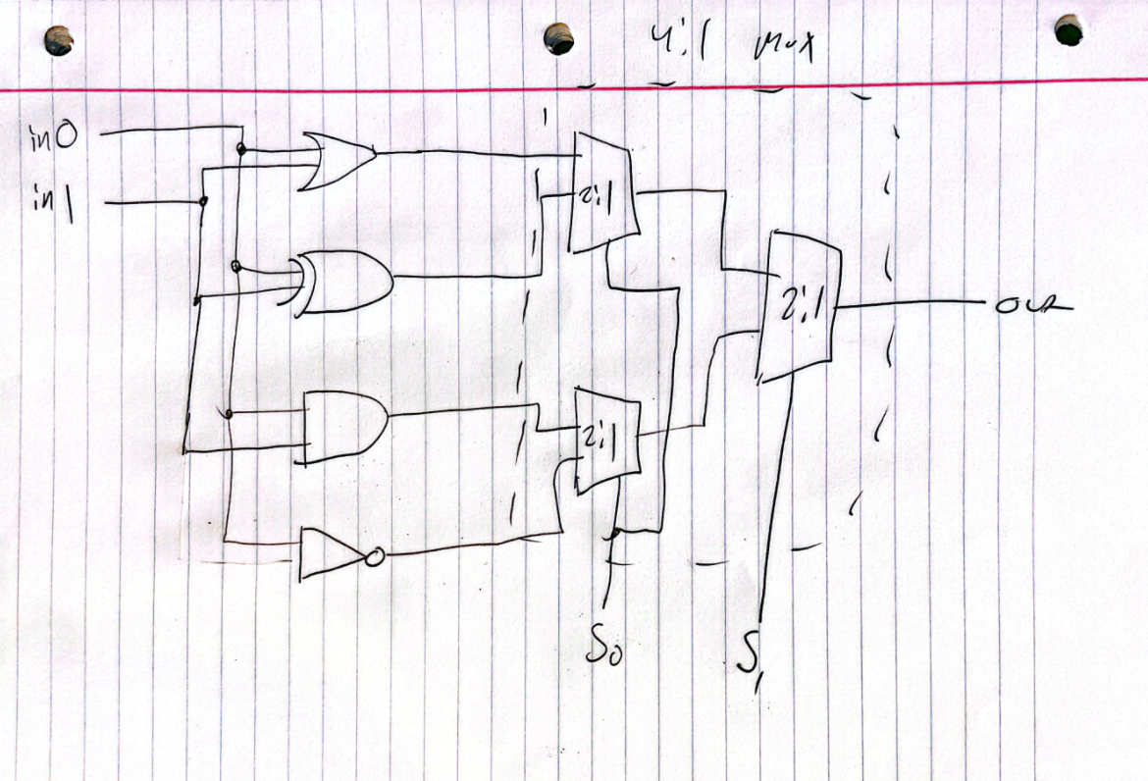
Section 3: 2:1 MUX on Hardware
- When we add LEDs as outputs for our 2:1 MUX hardware test, why do we still declare it as a vector, when we only need one? In other words, why not just use “led” without the vector index?
There are 10 total LEDs on the board (single color) and are defined in vector form. This keeps consistency with the constraints file, even though we only need 1 LED. We can later expand to use more LEDs in the vector if needed.
- Provide your final 2:1 MUX hardware module code below.
module mux21_hw(
sw, led
);
input [2:0] sw;
output [0:0] led;

assign led[0] = (sw[0] & ~sw[2]) | (sw[1] & sw[2]);

endmodule
- Fill in the truth table below.
Switch 2 | Switch 1 | Switch 0 | Predicted LED 0 State | Actual LED 0 State
0 | 0 | 0 | 0 | 0
0 | 0 | 1 | 1 | 1
0 | 1 | 0 | 0 | 0
0 | 1 | 1 | 1 | 1
1 | 0 | 0 | 0 | 0
1 | 0 | 1 | 0 | 0
1 | 1 | 0 | 1 | 1
1 | 1 | 1 | 1 | 1

Section 4: 4:1 MUX and Simulation
- Copy your 4:1 MUX code below.
module mux41(
in0, in1, in2, in3, s0, s1, out
);
input in3, in2, in1, in0;
input s1, s0;
output out;

wire temp1, temp0;

mux21 mux21_0(.in0(in0), .in1(in1), .s0(s0), .out(temp0));
mux21 mux21_1(.in0(in2), .in1(in3), .s0(s0), .out(temp1));
mux21 mux21_2(.in0(temp0), .in1(temp1), .s0(s1), .out(out));

endmodule
- Fill in the table with your 8 chosen test cases. Explain why you chose those combinations.
For each select available bit (s1s0 total of 4 cases), I first expect a zero output because I set all other available options to 1 (so that if I see a 1 I know something is wrong), then invert every input for the next case to expect a 1 on the output (and if I see 0 I know something is wrong). Repeat for each test case covers a general test of each case.
IN3 | IN2 | IN1 | IN0 | S1 | S0 | Predicted OUT | Actual OUT
1 | 1 | 1 | 0 | 0 | 0 | 0 | 0
0 | 0 | 0 | 1 | 0 | 0 | 1 | 1
1 | 1 | 0 | 1 | 0 | 1 | 0 | 0
0 | 0 | 1 | 0 | 0 | 1 | 1 | 1
1 | 0 | 1 | 1 | 1 | 0 | 0 | 0
0 | 1 | 0 | 0 | 1 | 0 | 1 | 1
0 | 1 | 1 | 1 | 1 | 1 | 0 | 0
1 | 0 | 0 | 0 | 1 | 1 | 1 | 1

Section 5: Logic Block
- If you updated your logic block from the pre-lab, include it below.
No
- Fill in the truth table below.
in1 | in0 | s1 | S0 | Predicted out | Testbench OUT
0 | 0 | 0 | 0 | 0 | 0
0 | 1 | 0 | 0 | 1 | 1
1 | 0 | 0 | 0 | 1 | 1
1 | 1 | 0 | 0 | 1 | 1
0 | 0 | 0 | 1 | 0 | 0
0 | 1 | 0 | 1 | 1 | 1
1 | 0 | 0 | 1 | 1 | 1
1 | 1 | 0 | 1 | 0 | 0
0 | 0 | 1 | 0 | 0 | 0
0 | 1 | 1 | 0 | 0 | 0
1 | 0 | 1 | 0 | 0 | 0
1 | 1 | 1 | 0 | 1 | 1
0 | 0 | 1 | 1 | 1 | 1
0 | 1 | 1 | 1 | 0 | 0
1 | 0 | 1 | 1 | 1 | 1
1 | 1 | 1 | 1 | 0 | 0

- Paste your simulation results below.
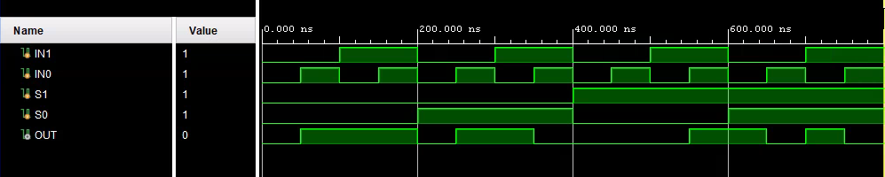
Post-Lab:
- Consider the 4:1 MUX we simulated in the lab. When s1:s0 = 10, which inputs matter, and which inputs do not?
Click or tap here to enter text.
- Now suppose you were testing this in hardware. Describe a fast way you could validate this particular case in hardware.
Click or tap here to enter text.
- Elaborate on this description; how would you quickly evaluate the full 4:1 MUX? Hint: Consider each set of select inputs to the MUX…which switches matter and which ones do not for each case?
Click or tap here to enter text.
- FPGAs are outstanding for developing and testing chip designs, because the chip design can be directly implemented on a piece of hardware before being sent out to be manufactured into an integrated circuit. At this stage, suppose our ultimate goal was to develop a new 8-bit MCU. Discuss how many errors/bugs you’ve had (relatively speaking) in the first two labs, and whether FPGA development has been worthwhile.
Click or tap here to enter text.
- FPGAs are also outstanding as a permanent part of a larger embedded system. Consider our homemade logic block as part of a larger system. Suppose we wanted to change which four logic functions are available. How difficult would it be to make this change?
Click or tap here to enter text.
- In the context of the above answer, describe, then, the advantage of using an FPGA for implementation in embedded systems.
Click or tap here to enter text.
- You have now performed all the functional tasks that we will be using in Vivado:
  - Create a project
  - Create a source module
  - Create a test bench and test your module
  - Import a constraint file
  - Create a module for testing your code on hardware
All of these things are outlined, step-by-step, in the lab manual, which you will have access to for your upcoming lab quiz at the beginning of Lab 4. Beyond that, the code for the source module will be quite simple. Reflect on whether you are comfortable doing these things, and how you will approach next week’s lab.
Click or tap here to enter text.

